**Supplemental material for the paper Homicides increased inequality of lifespans and slowed down life expectancy gains in Mexico, 2005-2015**

**Authors:** José Manuel Aburtoa & Hiram Beltrán-Sánchezb

**Author affiliations:**

a University of Southern Denmark, Odense 5000, Denmark. (jmaburto@health.sdu.dk)

b Department of Community Health Sciences at the Fielding School of Public Health and California Center for Population Research, Center for Health Sciences, Los Angeles, California, USA. (beltrans@ucla.edu)

**Abstract**

**Background** Mexico experienced an unprecedented rise of violence after 2005 related to the war on drugs.The net effect of rising homicides on health inequalities in the last decade is unknown.We quantify the effect of homicides on lifespan inequality and average lifespan in Mexico from 2005 to 2015.

**Methods** A cross-sectional retrospective demographic analysis with mortality data by cause of death was performed. Life expectancy and lifespan inequality conditional on surviving to age 15, as measured by years of life lost, with age- and cause-specific contributions of medically amenable conditions, diabetes, ischemic heart diseases, traffic accidents and homicides to the changes between 1995 and 2015 were calculated. National and subnational (32 states) populations by sex were analysed.

**Findings** Mexican male life expectancy at age 15 increased more than twice in 1995-2005 (1·17 years) than in 2005-2015 (0·55 years). Lifespan inequality decreased by more than half a year for males in 1995-2005 (from 14·31 to 13·77), while in 2005-2015, the reduction was about four times smaller. Homicides between ages 15-49 had the largest effect on slowing down male life expectancy and lifespan inequality in 2005-2015. At the state level, some states experienced reductions in life expectancy in 2005-2015 particularly in the North. In the same period five states showed a large increase in lifespan inequality. Although the increase in homicide mortality affected lifespan inequality in all states after 2005, one state in the South was affected the most (about 1 year increase for males and two months for females in Guerrero).

**Interpretation** After ten years of the unexpected increase of violence in Mexico, the country has not been able to reduce the levels homicides to those prior to 2005. Life expectancy improvements slowed down and inequality of lifespans increased among young Mexican males whereby young males are expected to die, on average, younger than in the recent past.

**Classification of causes of death**

|  |  |  |  |  |
| --- | --- | --- | --- | --- |
| **Category** | ICD 10 | | ICD 9 | |
| **I. Amenable to medical service** I.A. AM-Infectious & respiratory diseases : intestinal infections, tuberculosis, zoonotic bacterial diseases, other bacterial diseases, septicemia, poliomyelitis, measles, rubella, infectious hepatitis, ornithosis, rickettsioses/ arthropod-borne, syphilis (all forms), yaws, respiratory diseases, influenza & pneumonia, chronic lower respiratory diseases I.B. AM-Cancers: malignant neoplasm of colon, skin, breast, cervix, prostate, testis, bladder, kidney-Wilm’s tumor only, eye, thyroid carcinoma, Hodgkins disease, leukemia I.C. AM-Circulatory: active/acute rheumatic fever, chronic rheumatic heart disease, hypertensive disease, cerebrovascular disease I.D. AM-Birth: maternal deaths (all), congenital cardiovascular anomalies, perinatal deaths (excluding stillbirths) I.E. AM-Other: disease of thyroid, epilepsy, peptic ulcer, appendicitis, abdominal hernia, cholelithiasis & cholecystitis, nephritis, benign prostatic hyperplasia, misadventures to patients during surgical or medical care, cisticerchosis. | A00-A09, A16-A19, B90, A20-A26, A28, A32, A33, A35, A36, A37, A40-A41, A80, B05-B06, B15-B19, A70, A68, A75, A77, A50-A64, A66, J00-J08, J20-C50, C53, C61, C62, J39, J60-J99, J09-J18, J40-J47 C16,C18-C21, C43-C44, C67, C64, C69, C73, C81, C91-C95 I00-I02, I05-I09, I10-I13, I15, I60-I69, O00-O99, Q20-Q28, P00-P96 E00-E07, 40-G41, K25-K27, K35-K38, K40-K46, K80-K81, N00-N07, N17- N19, N25-N27, N40, Y60- Y69, Y83-Y84, B69 | | 001-009, 010-018, 32, 33, 37, 137, 020-027, 38, 45, 55-56, 70, 73, 080-082, 087, 090-099, 102, 460-479, 500-519, 480-488, 490-496 153-154, 172-173, 174, 180, 185, 186, 188-189, 190, 193, 201, 204-208 390-392, 393-398, 401-405, 430-438, 630-676, 745-747, 760-779, 240-246, 345, 531-533,540-543, 550-553, 574-575.1, 580-589, 600, E870-E876, E878-E879 | |
| **II. Diabetes** | | E10-E14 | | 250 |
| **III. Ischemic Heart Diseases (IHD)** | | I20-I25 | | 410-414, 429.2 |
| **IV. Lung cancer** | | C33-C34 | | 162 |
| **V. Cirrhosis** | | K70 | | 571.1-571.3 |
| **VI. Homicides** | | X85-Y09 | | E960-E969 |
| **VII. Road traffic accidents** | | V01-V99 | | E810-E819 |
| **VIII. Residual Causes** : HIV/AIDS; suicide and self-inflicted injuries; other cancers and other heart diseases | | B20-B24, U03; X60-X84, Y87.0; C00-D48; I00-I99 if not listed above; R00-R99 | | 042-044; E950-E959; 140-239; 390-459 if not listed above; 780-799 |

Source: Aburto, Beltrán-Sánchez, García-Guerrero, and Canudas-Romo (2016)

**Lifespan inequality indicator**

In lifetable notation, is defined as:

where and are the survival function, the force of mortality, life expectancy, the age at death distribution at age , and the open-aged interval, respectively.

**Code and data to reproduce results**

Available at <https://goo.gl/tQV6fL>.

**Shinny app for sensitivity and state specific analysis**

Results with starting age 0, available at <https://goo.gl/n9XuDy>

Results with starting age 15, available at <https://goo.gl/wy1miT>

**Supplemental figures. All figures are own calculations based on CONAPO (2017) and INEGI (2017) data.**

**Figure S1. Age-cause specific contributions to the changes in national life expectancy at age 15 for females. Panel A refers to 1995-2005 and panel B to 2005-2015. Note: Numbers in boxes are age-specific contributions.**

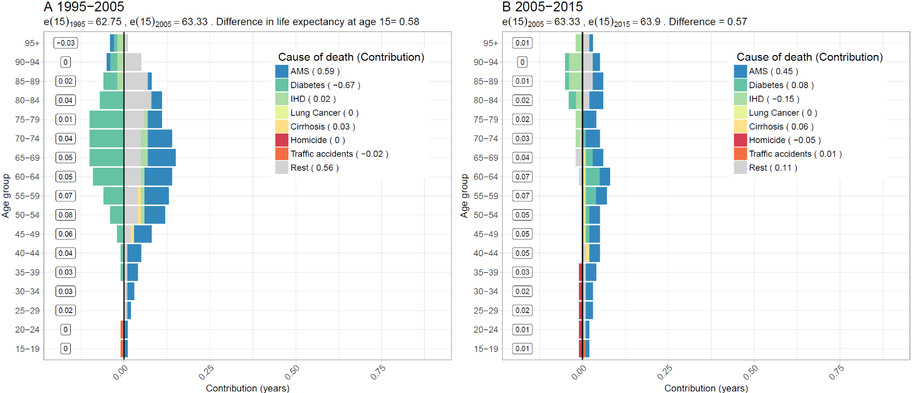

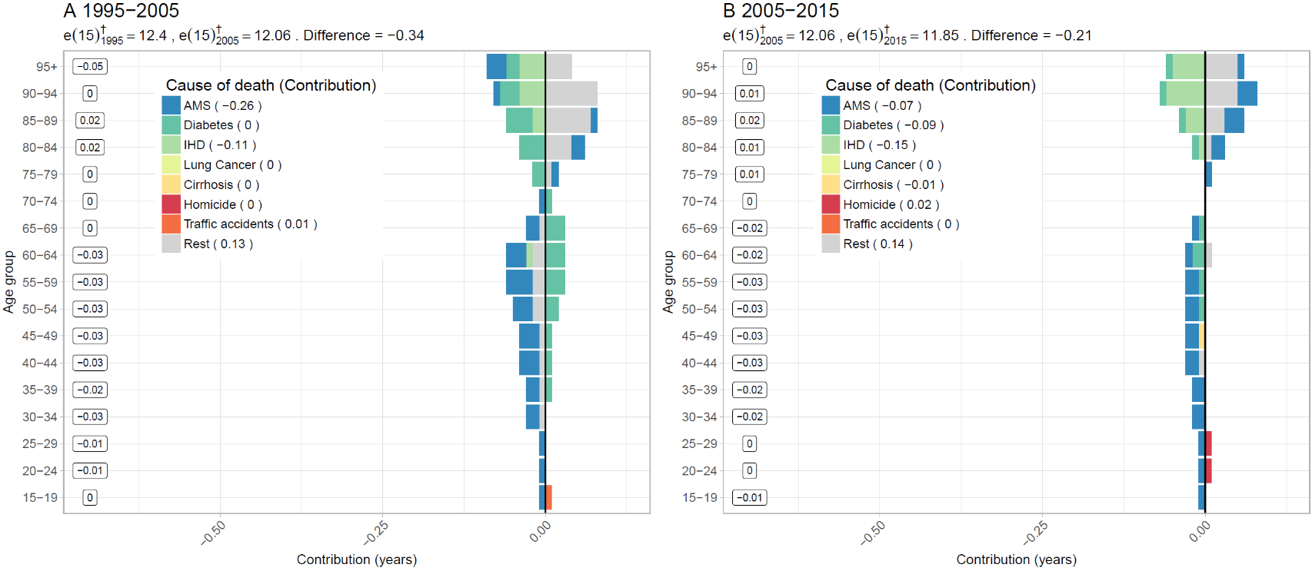**Figure S2. Age-cause specific contributions to the changes in national lifespan variation at age 15 () for females. Panel A refers to 1995-2005 and panel B to 2005-2015. Note: Numbers in boxes are age-specific contributions**

**Figure S3. Changes in female life expectancy (**e15**) (panel A) and female lifespan variation at age 15 () (panel 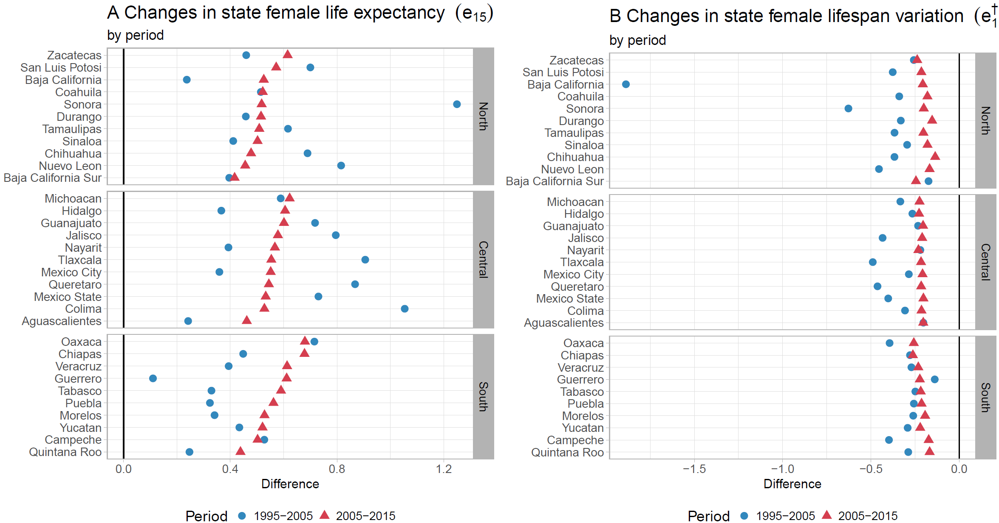B) by state for the periods 1995-2005 and 2005-2015**

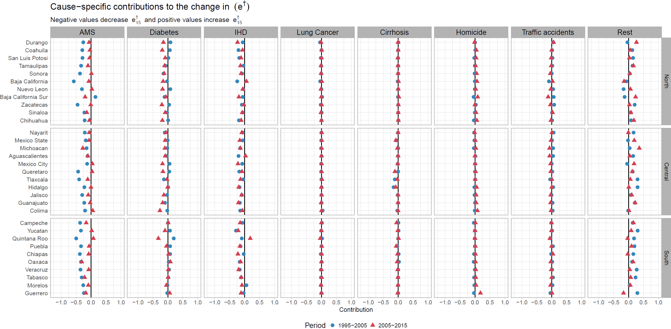**Figure S4. Cause-specific contributions to changes in female lifespan variation at age 15 () by state for the periods 1995-2005 and 2005-2015.**

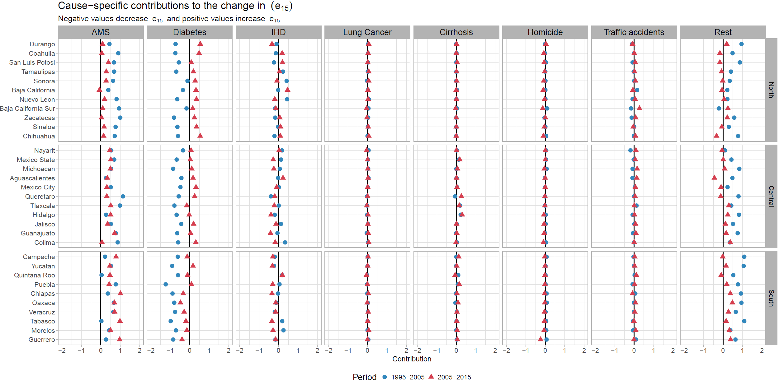**Figure S5. Cause-specific contributions to changes in female life expectancy at age 15 () by state for the periods 1995-2005 and 2005-2015.**

**Figure S6. Cause-specific contributions to changes in male lifespan variation at age 15 () by state for the periods 1995-2005 and 2005-2015.**

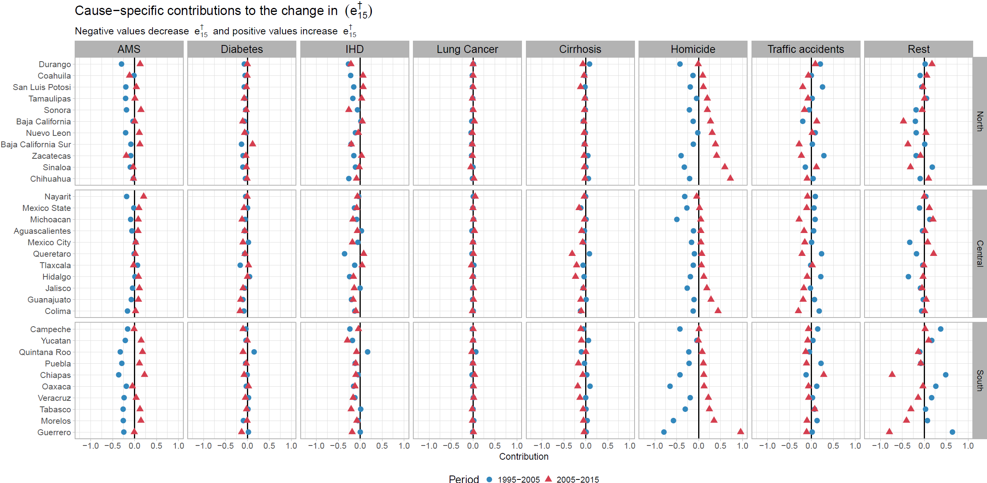

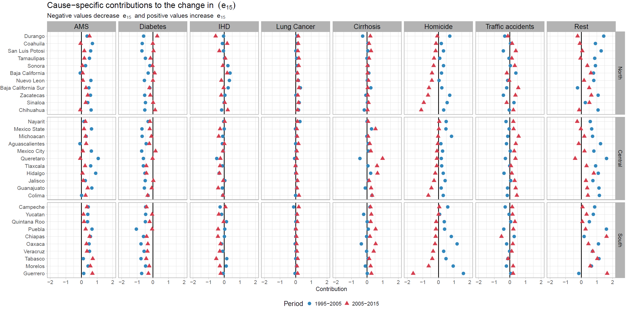**Figure S7. Cause-specific contributions to changes in male life expectancy at age 15 () by state for the periods 1995-2005 and 2005-2015.**

**References**

Aburto, J. M., Beltrán-Sánchez, H., García-Guerrero, V. M., & Canudas-Romo, V. (2016). Homicides in Mexico reversed life expectancy gains for men and slowed them for women, 2000–10. *Health Affairs, 35*(1), 88-95.

CONAPO. (2017). Mexican Population Council: Population estimates. Retrieved from <https://datos.gob.mx/busca/dataset/activity/proyecciones-de-la-poblacion-de-mexico>

INEGI. (2017). National Institute of Statistics: Micro-data files on mortality data 1995-2015. Retrieved from <http://www.beta.inegi.org.mx/proyectos/registros/vitales/mortalidad/default.html>